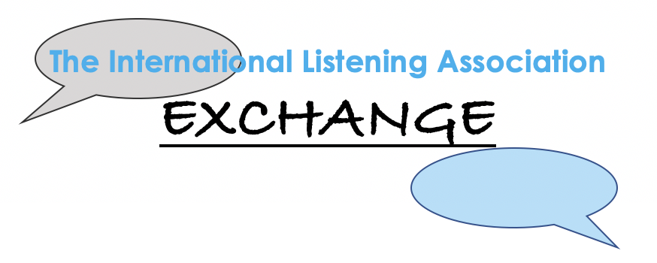
How to propose an ILA Exchange
The ILA Exchange is an online event to provide ILA members and friends with live, fun, interactive, learning opportunities. The aim is to enable us to “exchange” knowledge, skills, and experience in a creative, interactive format.
The Exchange is a special venue where participants are introduced to fresh perspectives on listening by dynamic presenters from around the world.
Due to its unique, engaging content and format, the ILA Exchange frequently books within the first few days of registration.
If you are an engaging, dynamic presenter and have great ideas and information about listening, the ILA invites you to apply to lead an ILA Exchange.
Guidelines ILA Exchange proposal:
Criteria:
- Events will be interactive and provide participants with an introduction to a new concept or skill.
- Presenters will be dynamic, engaging, and have expertise in their subject.
- Presenters should be willing to participate in a “dress-rehearsal” of their program and be open to feedback on delivery and content.
- The entire program will not exceed 60 minutes.
- We welcome creative delivery technique and unique subject matter related to Listening.

Benefits for Presenters:
- This is an opportunity for presenters to engage with an international audience from over to 25 countries worldwide.
- Participants normally comprise a dynamic range of professionals with widely varying interests: business, healthcare, education, academia, spirituality, music and much more.
- Discussion is positive, constructive, thought-provoking and creates opportunities for making international professional and personal connections.
- The ILA will promote Exchange program presenters and content to members and contacts worldwide.

To Apply:
- Complete proposal form below
- If you have questions, please contact Sandra Bodin-Lerner
Exchange Program Proposal Form

Speaker’s Name and Title
Speaker Bio
Title of Program
Objective
- What will the audience gain from the program?
- What is your personal objective?
Program Description (please be specific)
- Describe every aspect of your presentation (beginning, middle, end)
- Explain how the program will be interactive.
- Share any specific technical needs.
- How will the program be engaging and informative?
- Length?
Intended audience
- Who should attend?
- How many people can participate?
If possible, include video/audio samples of public speaking experience
Return completed proposal to Sandra Bodin-Lerner
What happens next:
- We will contact you to arrange to meet with member(s) of the ILA Exchange team for an online (Zoom/Skype/FaceTime) discussion of your proposal.
- Presenters who are selected to host an ILA Exchange online event will work with the Exchange team to determine an appropriate date for the program.
- Presenters will participate in a rehearsal of the program with Exchange team member(s).
- If you have questions, please contact Sandra Bodin-Lerner

