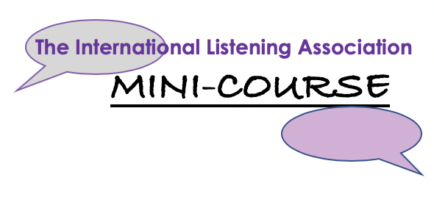
How to apply to run an ILA Mini-Course
The ILA Mini-Course is an online event series of related topics that provide ILA members and friends with on-going learning opportunities.
The ILA Mini-Course is a venue where a group of international experts in a specific field come together to offer online, thematic, informative sessions over a period of time.
If you are interested in developing an ILA Mini-Course, the ILA invites you to submit a proposal.
Overall Process leading to Course start: 6-weeks prior -- Submit complete proposal detailing ALL the events 4-weeks prior—Submit Announcement form with details for ALL the events 2-weeks prior – The first announcement goes out to ILA mail list 1-week prior—The second announcement goes out to ILA mail list
Criteria:
- Events will be interactive and linked with a common “listening” focused topic.
- Presenters will be dynamic, engaging, and have expertise in their subject.
- Presenters should be willing to participate in a “dress-rehearsal” of their program and be open to feedback on delivery and content.
- Each session for the entire program will not exceed 60 minutes.
- We welcome creative delivery technique and unique subject matter related to Listening.

Benefits for Presenters:
- This is an opportunity for presenters to engage with an international audience from over to 25 countries worldwide.
- Participants normally comprise a dynamic range of professionals with widely varying interests: business, healthcare, education, academia, spirituality, music and much more.
- Discussion is positive, constructive, thought-provoking and creates opportunities for making international professional and personal connections.
- The ILA will promote Exchange program presenters and content to members and contacts worldwide.

To Apply:
- Complete proposal form send to Sandra Bodin-Lerner

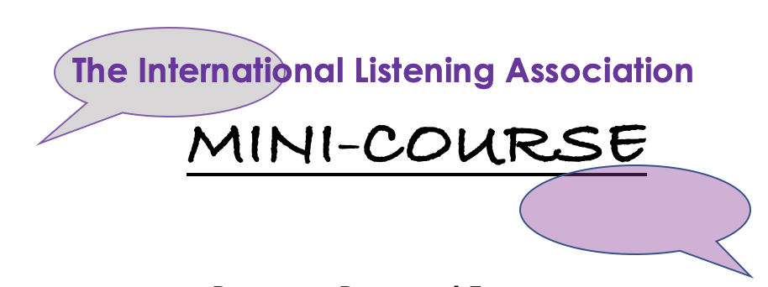
Program Proposal Form
Please provide for each session
Speaker(s) Name and Title
Speaker(s) Bio
Title of Program
Objective
- What will the audience gain from the program?
- What is your personal objective?
Program Description (please be specific)
- Describe every aspect of your presentation (beginning, middle, end)
- Explain how the program will be interactive.
- Share any specific technical needs.
- How will the program be engaging and informative?
- Length?

Intended audience. Who should attend?
- How many people can participate?
If possible, include video/audio samples of public speaking experience
Anticipated program Date Please submit proposal, at least, 6 weeks prior to proposed date. Note: We cannot guarantee requested date availability
Return completed form to Sandra Bodin-Lerner
What happens next:
- We will contact you to arrange to meet with member(s) of the ILA Events team for an online (Zoom/Skype/FaceTime) discussion of your proposal.
- Presenters who are selected to host an ILA Events online event will work with the Events team to determine an appropriate date for the program.
- Presenters will participate in a rehearsal of the program with Events team member(s).
- If you have questions, please contact Sandra Bodin-Lerner

Announcement Form
To help us prepare the announcement for the ILA Mini-Course please provide us with the following information, at least, 4 weeks prior to the start of course.
Note: This information will be used to create announcements, note that due to space limitations, not all the information will be included.
Mini-Course Title: _____________________________
Total number of sessions: _________________________
Brief, 1-4 sentence, description of overall Mini-Course: _______________________________
____________________________________________________________________________
Schedule of events:
- Title 1st Program _______________________________________ Day, Month date, time (US Central Time) ____________________________
Speaker (title, Country) ___________________________________________
- Title 2nd Program _______________________________________ Day, Month date, time (US Central Time) ____________________________
Speaker (title, Country) ___________________________________________
- Title 3rd Program _______________________________________ Day, Month date, time (US Central Time) ____________________________
Speaker (title, Country) ___________________________________________
- Title 4th Program_______________________________________ Day, Month date, time (US Central Time) ____________________________
Speaker (title, Country) ___________________________________________
- Title 5th Program _______________________________________ Day, Month date, time (US Central Time) ____________________________
Speaker (title, Country) ___________________________________________

